# **Troubleshooting**

## **Objectives**

**5.1 Troubleshoot data object management query failures**

Syntax and runtime errors

**5.2 Troubleshoot data retrieval query failures**

Syntax and runtime errors

**5.3 Troubleshoot data manipulation query failures**

Syntax and runtime errors

-----------------------------------------------------------------------------------------

## Domain

### Pre-Assessment

Q1: Syntax Errors (ID 27905) = V

Which statement best defines a syntax error?

Causes tables to not appear correctly within a database

Prevents a table from being created

Causes a statement not to run

Prevents changes to a database from being completed

**Causes a statement not to run**

Q2: Common DRL Errors (ID 27906) = V

One error that may occur is attempting to retrieve data with a well-written query but against the wrong ___.

Row

Database

Column

Table

**Database**

Q3: Common DML Errors (ID 27907) = V

One error that may occur when manipulating data is a missing ___.

Column

Query

Table

Keyword

**Keyword**

### Videos

Object Management Errors

ALTER BikeRepairs

ADD COLUMN EmployeeID int

*Msg 343, Level 16, State 1, Line 1*

*Unknown object type ‘BikeRepairs’ used in a CREATE, DROP, or ALTER statement.*

ALTER TABLE BikeRepairs

ADD COLUMN EmployeeID int

*Msg 156, Level 16, State 1, Line 2*

*Incorrect syntax near the keyword ‘COLUMN’.*

ALTER TABLE BikeRepairs

ADD EmployeeID int

*Commands completed successfully.*

ALTER TABLE BikeRepairs

ADD EmployeeID int

*Msg 2705, Level 16, State 4, Line 1*

*Column names in each table must be unique. Column name ‘EmployeeID’ in table ‘BikeRepairs’ is specified more than once.*

Select Errors

SELECT Sales.Customer.CustomerID,

Sales.Customer.AccountNumber,

OrderDate,

Status,

FROM Sales.Customer

JOIN Sales.SalesOrderHeader on Sales.Customer.CustomerID

= Sales.SalesOrderHeader.CustomerID

*Msg 156, Level 16, State 1, Line 5*

*Incorrect syntax near the keyword ‘FROM’.*

***AdventureWorks2019 database:***

SELECT Sales.Customer.CustomerID

,Sales.Customer.AccountNumber

,OrderDate

,Status

FROM Sales.Customer

JOIN Sales.SalesOrderHeader on Sales.Customer.CustomerID

= Sales.SalesOrderHeader.CustomerID

*Command completed successfully*

***BikeRepair database:***

SELECT Sales.Customer.CustomerID

,Sales.Customer.AccountNumber

,OrderDate

,Status

FROM Sales.Customer

JOIN Sales.SalesOrderHeader on Sales.Customer.CustomerID

= Sales.SalesOrderHeader.CustomerID

*Msg 208, Level 16, State 1, Line 1*

*Invalid object name ‘Sales.Customer’.*

***BikeRepair database:***

USE AdventureWorks2019

SELECT Sales.Customer.CustomerID

,Sales.Customer.AccountNumber

,OrderDate

,Status

FROM Sales.Customer

JOIN Sales.SalesOrderHeader on Sales.Customer.CustomerID

= Sales.SalesOrderHeader.CustomerID

*Command completed successfully.*

Data Manipulation Errors

INSERT BikeRepairs (BikeRepairID, CustomerID, StartDate, EstHour, EstRate)

(1, 101, ‘2021-07-01’,5,20),

(2, 101, ‘2021-07-01’,2,20)

*Msg 102, Level 16, State 1, Line 4*

*Incorrect syntax near ‘1’.*

INSERT BikeRepairs (BikeRepairID, CustomerID, StartDate, EstHour, EstRate)

VALUES

(1, 101, ‘2021-07-01’,5,20),

(2, 101, ‘2021-07-01’,2,20)

*Msg 2601, Level 14, State 1, Line 1*

*Cannot insert duplicate key row in object ‘dbo.BikeRepairs’ with unique index ‘ClusteredIndex-20210630-120329’. The duplicate key value is ………*

### Labs/Post-Assessment

Q1: A (ID 27908) = V

Refer to the image. What type of error is shown in the query?

Command error

Syntax error

Runtime error

Operator error

**Syntax error**

Q2: B (ID 27909) = V

Refer to the image. What type of error is shown in the query?

Command error

Syntax error

Runtime error

Operator error

**Runtime error**

Q3: C (ID 27910) = V

Refer to the image. What is the syntax error in the query?

The Sales.Customer table is not the correct table

The SELECT statement should be a SELECT INTO statement

There is a comma after the first column listed in the query

There is a comma after the last column listed in the query

**There is a comma after the last column listed in the query**

Q4: D (ID 27911) = V

Refer to the image. What is the runtime error in the query?

The Sales.Customer table has not been created yet

The query is being run against the wrong database

There are too many columns from which data is being taken

The wrong type of join is used

**The query is being run against the wrong database**

Q5: E (ID 27912) = V

Refer to the image. What is the syntax error in the query?

The ADD keyword is missing

The HAVING clause is missing

The VALUES keyword is missing

There should not be a comma after the first record that is being added

**The VALUES keyword is missing**

Q6: F (ID 27913) = V

Refer to the image. What is the runtime error in the query?

The primary key entry is being duplicated

There are too many values being added at once

The INSERT statement should be a SELECT statement

The values are being added to the wrong database

**The primary key entry is being duplicated**

## Quiz

Q1: Fill in the blanks, using the dropdown menus.

A ___ error will cause a SQL statement not to run whereas a ___ error will appear when the code is syntactically correct but the action being attempted is not allowed.

**Syntax, runtime**

Q2: The table 'Low_Price_Meals' is shown below. The 'id' field is the primary key field. 5 records are stored in the table.

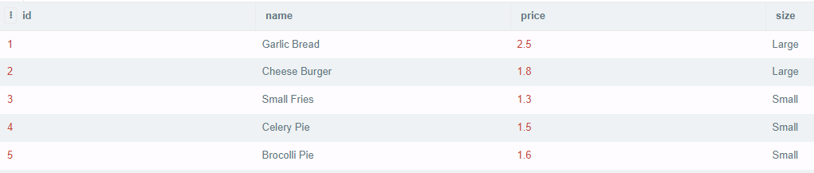

You wish to write a SQL statement that copies the records in the table to a new table called 'Meal_Deals'.

The 'Meal_Deals' table does not exist.

You execute the following query, what will be the outcome?

INSERT INTO Meal_Deals (id, name, price, size)

SELECT id, name, price, size FROM Low_Price_Meals;

The SQL statement executes correctly and 10 records are copied to the Meal_Deals table.

A runtime error

The SQL statement executes correctly and 5 records are copied to the Meal_Deals table.

A syntax error

**A runtime error**

Q3: How many syntax errors are there in this SQL statement?

ALTER BikeRepairs ADD COLUMN EmployeeID int;

2

1

0

More than 2

**2**

Q4: Assume that a table named BikeRepairs exists and has a column named EmployeeID. Given the following SQL statement:

ALTER TABLE BikeRepairs

ADD EmployeeID int;

What will be the result of running the above SQL statement?

A runtime error

No error(s) reported

A syntax error

The result is unpredictable.

**A runtime error**

Q5: Given the SQL statement below, is this an example of a syntax error or a runtime error?

SELECT Sales.Customer.CustomerID,

Sales.Customer.AccountNumber,

OrderDate,

Status,

FROM Sales.Customer

JOIN Sales.SalesOrderHeader on Sales.Customer.CustomerID = Sales.SalesOrderHeader.CustomerID;

A runtime error

A syntax error

**A syntax error**

Q6: To ensure that a query is running against the correct database, which SQL statement can be specified at the beginning of a query?

DROP

UPDATE

GRANT

SELECT

USE

**USE**

Q7: Given that a table named BikeRepairs exists and currently holds no records, what will happen when the following query is executed?

Assume that the column names listed in the SQL statement correctly match the columns defined in the BikeRepairs table.

INSERT BikeRepairs (BikeRepairID, CustomerID, StartDate, EstHour, EstRate)

(1, 101, '2021-07-01', 5, 20),

(2, 101, '2021-07-01', 2, 20);

The statement will fail to execute because of a syntax error.

The statement will execute correctly and two records will be inserted into the table.

It is impossible to determine whether there is a problem with the statement.

The statement will fail to execute because of a runtime error.

**The statement will fail to execute because of a syntax error.**

Q8: Given that a table named BikeRepairs exists and holds three records. The primary key field in the table is BikeRepairID.

Refer to the screenshot below.



What will be the outcome of trying to execute the following SQL statement?

INSERT BikeRepairs (BikeRepairID, CustomerID, StartDate, EstHour, EstRate)

VALUES

(1, 101, '2021-07-01', 5, 20),

(2, 101, '2021-07-01', 2, 20);

A syntax error

The SQL statement executes correctly and the table now has 5 records.

A runtime error

The SQL statement executes correctly and the table now has 4 records.

**A runtime error**

Q9: The table 'Low_Price_Meals' is shown below. The 'id' field is the primary key field.

Refer to the screenshot below:

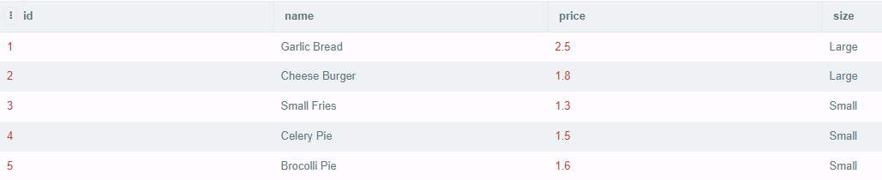

What will be the result of executing the following query?

INSERT Low_Price_Meals (id, name, price, size)

VALUES

(6, 'Hamburger', 2.50, 'small'),

(7, 'Onion Rings',1.90, 'small');

A syntax error

The SQL statement executes correctly and the table now has 7 records.

A runtime error

The SQL statement executes correctly and the table now has 10 records.

**The SQL statement executes correctly and the table now has 7 records.**

Q10: Given that the following SQL query is written to retrieve data from the AdventureWorks2019 database.

SELECT Sales.Customer.CustomerID,

Sales.Customer.AccountNumber,

OrderDate,

Status

FROM Sales.Customer

JOIN Sales.SalesOrderHeader on

Sales.Customer.CustomerID =

Sales.SalesOrderHeader.CustomerID;

In error, the DBA has selected the BikeRepairs database from the available databases field in SQL Server Management Studio.

When the above SQL statement executes, the result is a syntax error: true or false?

**False**